**Training Manager**

*Database Design*

**1. Entity Relationship Diagram (ERD)**

An entity relationship diagram (ERD) shows the relationships of entity sets stored in a database. An entity in this context is an object, a component of data. An entity set is a collection of similar entities. These entities can have attributes that define its properties.

By defining the entities, their attributes, and showing the relationships between them, an ER diagram illustrates the logical structure of databases.

ER diagrams are used to sketch out the design of a database.

The following picture illustrates the ER Diagram for the Training Manager database:

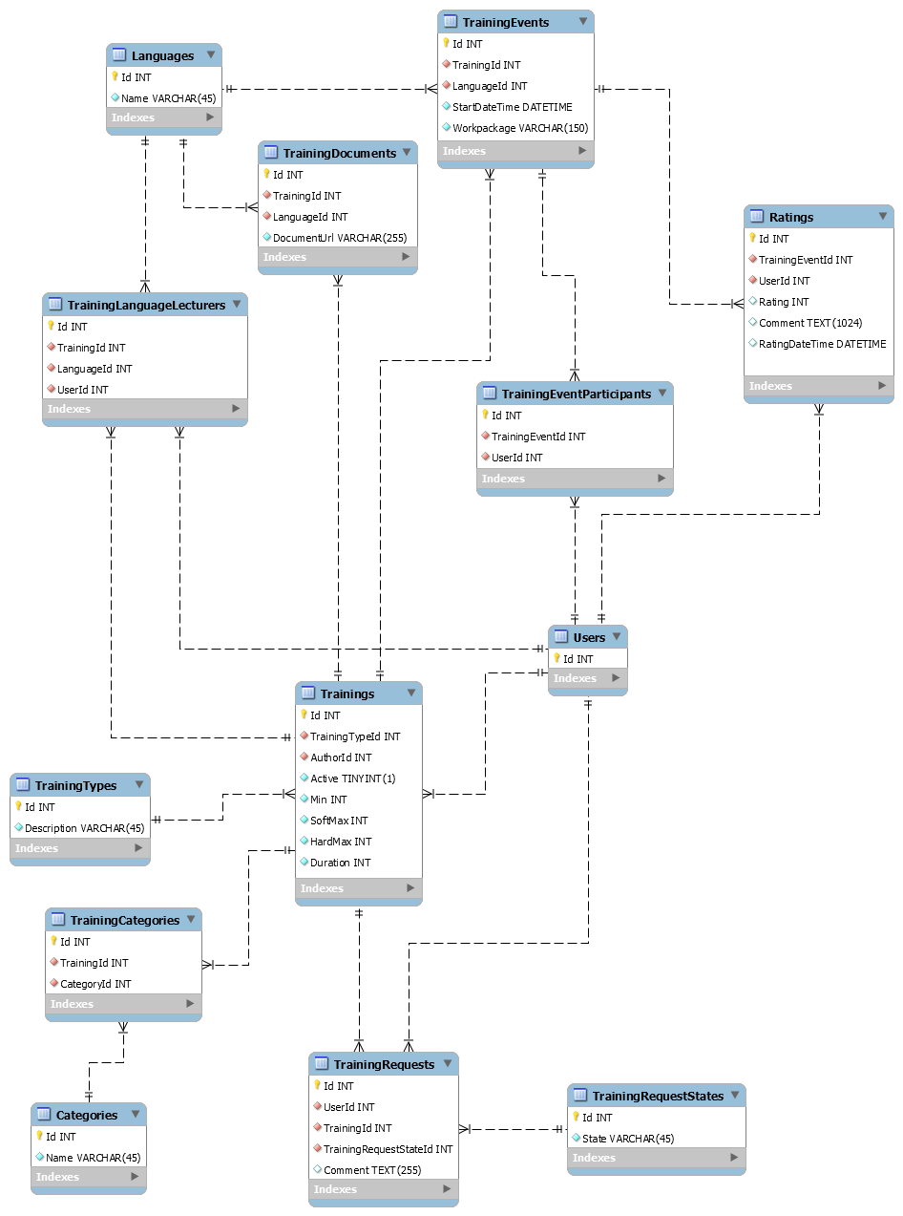

**2. Relational model**

The relational model (RM) for database management is an approach to managing data using a structure and language consistent with first-order predicate logic, where all data is represented in terms of tuples, grouped into relations.

Below is the relational model for the Training Manager application.

**Trainings** – ( Id, *TrainingTypeId*, *AuthoreId*, Active, Min, SoftMax, HardMax, Duration)

**TrainingEvents** – ( Id, *TrainingId*, *LanguageId*, StartDateTime, Workpackage)

**TrainingDocuments** – ( Id, *TrainingId*, *LanguageId*, DocumentUrl )

**Ratings** – ( Id, *TrainingEventId*, *UserId*, Rating, Comment, RatingDateTime )

**Categories** – ( Id, Name )

**TrainingCategories** ( Id, *TrainingId*, *CategoryId*)

**Users** – ( Id )

**Languages** ( Id, Name )

**TrainingTypes** ( Id, Description )

**TrainingRequests** ( Id, *UserId*, *TrainingId, TrainingRequestStateId*, Comment)

**TrainingRequestStates** (Id, State)

**TrainingEventParticipants** ( Id, *TrainingEventId*, *UserId*)

**TrainingLanguageLecturers** ( Id, *TrainingId*, *LanguageId*, *UserId*)

**3. Documentation of the database Training Manager**

**3.1 Trainings table**

The Trainings table should provide information’s about available trainings and should be used to add new trainings, delete or update existing trainings.

|  |  |  |  |
| --- | --- | --- | --- |
| Column name | Datatype | Description | Definitions |
| Id | Integer | Identity column | Not Null, primary Key |
| TrainingTypeId | Integer | Identity column from training type table | Not Null, foreign Key |
| AuthorId | Integer | Identity column from user table | Not Null, foreign key |
| Active | Tinyint | Sets training as active or inactive | Not Null |
| Min | Integer | Min numbers of participants | Not Null |
| SoftMax | Integer | Soft max numbers of participants | Not Null |
| HardMax | Integer | Hard max numbers of participants | Not Null |

**3.2 TrainingEvents table**

The TrainingEvents table contains information about which training in which language are available.

It should be possible to add, update or delete data from this table.

|  |  |  |  |
| --- | --- | --- | --- |
| Column name | Datatype | Description | Definitions |
| Id | Integer | Identity column | Not Null, primary Key |
| TrainingId | Integer | Identity column from training table | Not Null, foreign Key |
| LanguageId | Integer | Identity column from language table | Not Null, foreign key |
| StartDateTime | DateTime | Training start Date/Time | Not Null |
| Workpackage | Varchar(150) | Path to the Workpackage in ProjektXT | Not Null |

**3.3 TrainingDocuments table**

The TrainingDocuments table contains information about which training documentation and in which language are available. It should be possible to add, update or delete data from this table.

|  |  |  |  |
| --- | --- | --- | --- |
| Column name | Datatype | Description | Definitions |
| Id | Integer | Identity column | Not Null, primary Key |
| TrainingId | Integer | Identity column from training table | Not Null, foreign Key |
| LanguageId | Integer | Identity column from language table | Not Null, foreign key |
| DocumentUrl | Varchar(255) | Url for a training document uploaded in Vibe | Not Null |

**3.4 Ratings table**

The Ratings table contains information about the ratings for each performed training event and who had given a rate.

|  |  |  |  |
| --- | --- | --- | --- |
| Column name | Datatype | Description | Definitions |
| Id | Integer | Identity column | Not Null, primary key |
| TrainingEventId | Integer | Identity column from training event table | Not Null, foreign key |
| UserId | Integer | Identity column from user table | Not Null, foreign key |
| Rating | Integer | 0-5 star rating for training | Null |
| Comment | Text(1024) | Comment in addition to training event rating | Null |

**3.5 Categories table**

The Categories table contains information about training categories.

It should be possible to add, update or delete data from this table.

|  |  |  |  |
| --- | --- | --- | --- |
| Column name | Datatype | Description | Definitions |
| Id | Integer | Identity column | Not Null, primary Key |
| Name | Varchar(45) | Category name | Not Null |

**3.6 TrainingCategories table**

The TrainingCategories table contains information about which training is part of which category.

It should be possible to add, update or delete data from this table.

|  |  |  |  |
| --- | --- | --- | --- |
| Column name | Datatype | Description | Definitions |
| Id | Integer | Identity column | Not Null, primary Key |
| TrainingId | Integer | Identity column from course table | Not Null, foreign key |
| CategoryId | Integer | Identity column from category table | Not Null, foreign key |

**3.7 Users table**

The Users table contains information about logged in user.

It should be possible to add, update or delete data from this table.

|  |  |  |  |
| --- | --- | --- | --- |
| Column name | Datatype | Description | Definitions |
| Id | Integer | Identity column | Not Null, primary Key |

**3.8 Languages table**

The Language table contains information about languages.

It should be possible to add, update or delete data from this table.

|  |  |  |  |
| --- | --- | --- | --- |
| Column name | Datatype | Description | Definitions |
| Id | Integer | Identity column | Not Null, primary Key |
| Name | Varchar(45) | Language name | Not Null |

**3.9 TrainingTypes table**

The TrainingTypes table contains information about training types.

It should be possible to add, update or delete data from this table.

|  |  |  |  |
| --- | --- | --- | --- |
| Column name | Datatype | Description | Definitions |
| Id | Integer | Identity column | Not Null, primary Key |
| Description | Varchar(45) | Training type description | Not Null |

**3.10 TrainingRequests table**

The TrainingRequests table should provide information’s about all training requests requested by a specific user.

It should be possible to add, update or delete data from this table.

|  |  |  |  |
| --- | --- | --- | --- |
| Column name | Datatype | Description | Definitions |
| Id | Integer | Identity column | Not Null, primary Key |
| UserId | Integer | Identity column from user table | Not Null, foreign Key |
|  |  |  |  |
| TrainingId | Integer | Identity column from training table | Not Null, foreign key |
| TrainingRequestStateId | Integer | Identity column from training request state table | Not Null, foreign key |
| Comment | Text (255) | Comment regarding specific training request | Null |

**3.11 TrainingRequestStates table**

The TrainingStates table contains information about which state a training request can have.

It should be possible to add, update or delete data from this table.

|  |  |  |  |
| --- | --- | --- | --- |
| Column name | Datatype | Description | Definitions |
| Id | Integer | Identity column | Not Null, primary key |
| State | Integer | Training request state | Not Null |

**3.12 TrainingEventParticipants table**

The TrainingEventParticipants table contains information about all participants for a training event.

It should be possible to add, update or delete data from this table.

|  |  |  |  |
| --- | --- | --- | --- |
| Column name | Datatype | Description | Definitions |
| Id | Integer | Identity column | Not Null, primary key |
| TrainingEventId | Integer | Identity column from training event table | Not Null, foreign key |
| UserId | Integer | Identity column from user table | Not Null, foreign key |

**3.13 TrainingLanguageLecturers table**

The TrainingLanguageLecturers table contains information about trainings and training lecturer and in which language the training will be performed.

It should be possible to add, update or delete data from this table.

|  |  |  |  |
| --- | --- | --- | --- |
| Column name | Datatype | Description | Definitions |
| Id | Integer | Identity column | Not Null, primary Key |
| TrainingId | Integer | Identity column from training table | Not Null, foreign Key |
| LanguageId | Integer | Identity column from language table | Not Null, foreign key |
| UserId | Integer | Identity column from user table | Not Null, foreign key |